

**School of Mechanical & Manufacturing Engineering (SMME),**

**National University of Science and Technology (NUST),**

**Sector H-12, Islamabad**

**ED ASSIGNMENT # 1: ORTHOGRAPHIC PROJECTIONS**

|  |  |
| --- | --- |
| **Name:** Al Ameerah Bint E Waqar  **Program**: BE- Aerospace  **Session**: Spring 2024  **Course title**: Engineering Drawing | **CMS: 480966**  **Section**: AE-01  **Semester**: 2nd  **Date**: 3-05-24 |

AEROSPACE ENGINEERING | SMME

GROUP: 1

# Objective

To proficiently create orthographic projections of three-dimensional objects using AutoCAD, enhancing understanding of projection principles and 3D-to-2D representation.

# Definitions and Key Points

* **Orthographic Projection:**

Orthographic projection is a method of representing a three-dimensional object in two dimensions. It involves projecting the object onto two or more perpendicular planes, typically front, top, and side views, to accurately depict its shape and dimensions. This technique is commonly used in engineering, architecture, and design to communicate the form and details of objects.

* **Views:**

Orthographic projection requires multiple views to fully describe the object. The primary views include the front, top, and side views, which are mutually perpendicular and provide comprehensive information about the object's geometry. Additional views may be necessary for complex objects to capture all relevant details.

* **Projection Lines and Planes:**

Projection lines are imaginary lines drawn from points on the object to corresponding points on the projection plane. These lines represent the path along which the object is projected onto the plane. Projection planes are imaginary flat surfaces onto which the views of the object are projected. In orthographic projection, each view is projected onto its own plane, ensuring accuracy and clarity in the representation of the object.

* **Principles of Orthographic Projection:**

The principles of orthographic projection dictate how the views of the object are aligned and projected onto the respective planes. These principles include:

1. Orthogonality: Projection lines are perpendicular to the projection plane, ensuring that the views are true representations of the object.
2. Projection Direction: Each view is projected in a specific direction relative to the object, such as front, top, or side, to capture different perspectives.
3. Projection Alignment: Views are aligned such that corresponding features of the object are positioned consistently across different views, facilitating accurate dimensioning and interpretation.

* **Dimensioning and Annotation:**

Dimensioning is the process of adding measurements to the orthographic views to indicate the size and proportions of the object. This includes linear dimensions, such as lengths and widths, as well as angular dimensions for angles and orientations. Annotation involves labeling key features of the object, such as vertices, edges, and surfaces, to provide additional context and clarity in the drawings.

* **Importance of Orthographic Projection:**

Orthographic projection is essential in engineering, architecture, and design for accurately representing three-dimensional objects in two dimensions. It allows designers and engineers to communicate complex geometries, visualize spatial relationships, and convey design intent effectively. Mastery of orthographic projection techniques is therefore fundamental for professionals in these fields to create precise technical drawings and facilitate clear communication in the design process.

# Procedure

The procedure followed to make the drawings was as follows:

**Step 1: Setting up the Drawing Environment**

* Opened AutoCAD and adjust snap object settings.
* Set up the grid and adjusted the display settings for optimal visibility.

**Step 2: Generating Orthographic Views**

* For each 3D object, generated front, top, and side views.
* Aligned the object with the appropriate axis before projecting the views onto the respective planes.
* Used AutoCAD's view command to create separate viewports for each orthographic view.

**Step 3: Dimensioning and Annotation**

* Added dimensions to each orthographic view to indicate the object's size and proportions.
* Labeled key features of the object, such as vertices, edges, and faces, to provide additional clarity.

**Step 4: Finalizing the Drawings**

* Reviewed the orthographic projections to ensure accuracy and completeness.
* Made any necessary adjustments to improve the clarity and presentation of the drawings.

# Drawings

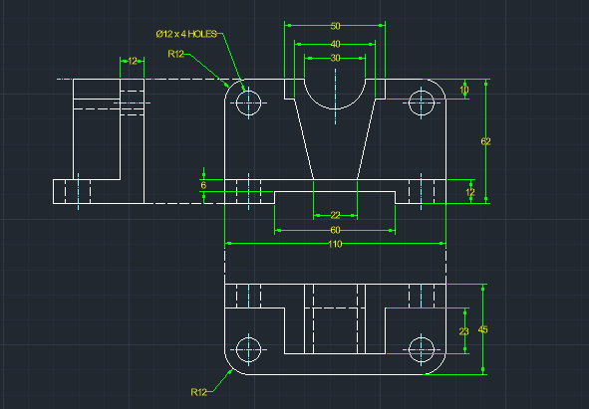

*Figure 1: Orthographic Projection of Drawing 1*

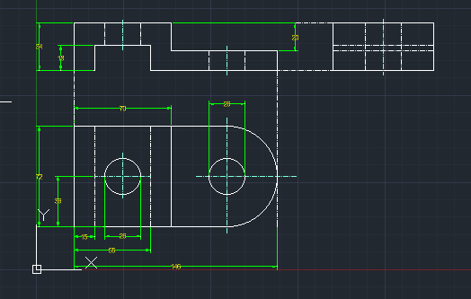

*Figure 2: Orthographic Projection of Drawing 2*

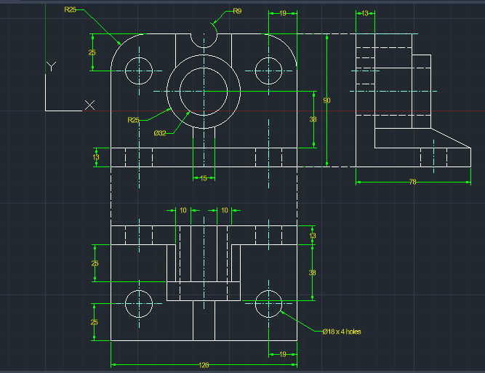

*Figure 3: Orthographic Projection of Drawing 3*